UNIT 2: CLOTHING
Look at the dress these people are wearing. Decide where each person comes from.
(Nhìn y phục những người này đang mặc. Quyết định mỗi người từ đâu đến.)
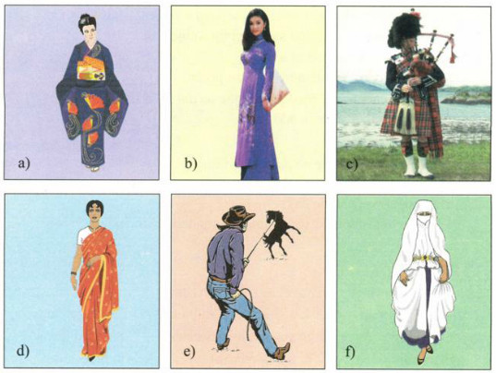
Suggested answers
a. She comes from Japan. (She’s wearing Kimono.)
b. She comes from Viet Nam. (She’s wearing ao dai.”
c. He comes from Scotland. (He’s wearing kilt.)
d. She comes from India. (She’s wearing sari.)
e. He comes from the western part of the United States. (He’s wearing T-shirt and jeans.)
f. She comes from an Islamic country. (She’s wearing Burqa.)

LISTEN AND READ
For centuries, poets, writers and musicians have mentioned the ao dai in poems, novels and songs. The ao dai is the traditional dress of Vietnamese women. It consists of a long silk tunic that is slit on the sides and worn over loose pants. Traditionally, it was frequently worn by both men and women. The design and material used for men were different from those used for women. Nowadays, women usually wear it, especially on special occasions. However, many Vietnamese women today often prefer to wear modern clothing at work, because it is more convenient.
Now fashion designers want to change the traditional ao dai. Some have printed lines of poetry on the ao dai, so they look modern and very fashionable. Other designers have taken inspiration from Vietnam’s ethnic minorities.
They have visited villages and studied traditional designs and symbols such as suns, stars, crosses, and stripes. They have added these patterns to the ao dai, so Vietnamese women can continue to wear the unique dress, which is now both traditional and fashionable.
VOCABULARY:

1 | poet/ poem/ poetry (n.)  poetic (a.)  poetically (adv.)  lines of poetry (n.) | /ˈpoʊət/, /ˈpoʊəm/, /ˈpoʊətri/  /poʊˈet̬ɪk/ /poʊˈet̬ɪkəli/ | nhà thơ/ bài thơ/ thơ ca  những câu/ dòng thơ
2 | mention (v.) | /ˈmenʃən/ | đề cập đến, nói đến
3 | wear- wore- worn (v.)  = put on | /wer/, /wɔːr/, /wɔːrn/ | Mặc, đội, mang
4 | tunic (n.) | /ˈtjuːnɪk/ | (Quần áo) rộng và chùng
5 | slit (n.)  slit/ slit/ slit (v.) | /slɪt/ | Đường xẻ  xẻ, chẻ, rọc ra
6 | loose (a.) # tight  loosen (v.) | /luːs/, /taɪt/  /ˈluːsən/ | rộng, lòng thòng
7 | design (n.)  design (n.)  fashion designer (n.) | /dɪˈzaɪn/  /dɪˈzaɪn/  /ˈfæʃən dɪˈzaɪnɚ/ | Thiết kế, vẽ kiểu (quần áo…)  kiểu dáng thiết kế  nhà thiết kế
8 | material (n.) | /məˈtɪriəl/ | chất liệu
9 | modern (a.)  modernity (n.)  modernize/se (v.)  modernization (n.) | /ˈmɑːdɚn/  /mɑːˈdɝːnət̬i/  /ˈmɑːdɚnaɪz/  /ˌmɑːdɚnəˈzeɪʃən/ | hiện đại  hiện đại hóa
10 | (in) convenient (a.)  (in) convenience (n.)  (in) conveniently (adv.) | /(ɪn) kənˈviːni.ənt/  /(ɪn) kənˈviːnjəns/  /(ɪn) kənˈviːnjəntli/ | (bất) tiện lợi
11 | fashion (n.)  fashionable (a.)  fashionably (adv.)  old- fashioned (a.)  out of fashion (exp.) | /ˈfæʃən/  /ˈfæʃənəbəl/  /ˈfæʃənəbli/  /ˌoʊldˈfæʃənd/ | thời trang  hợp thời trang  lạc hậu, không hợp thời  lỗi thời
12 | inspiration (n.)  inspirational (a.)  inspire (v.)  take inspiration from | /ˌɪn.spəˈreɪʃən/  /ˌɪnspəˈreɪʃənəl/ | cảm hứng  truyền cảm hứng  lấy cảm hứng từ
13 | minority (n.) (ies. pl.) minor (a.)  ethnic minority (n.) | /maɪˈnɔːrət̬i/  /ˈmaɪnɚ/  /ˌeθnɪk maɪˈnɑːrət̬i/ | thiểu số  thứ yếu  dân tộc thiểu số
14 | symbol (n.)  symbolize (v.) | /ˈsɪmbəl/  /ˈsɪmbəlaɪz/ | biểu tượng
15 | cross (n.) | /krɑːs/ | dấu chéo, chữ thập
16 | stripe (n.)  striped (a.) | /straɪp/  /straɪpt/ | sọc, vạch kẻ  có sọc
17 | Pattern (n.) | /ˈpæt̬.ɚn/ | mẫu kiểu
18 | unique (a.) uniquely (adv.)  uniqueness (n.) | /juːˈniːk/  /juːˈniːk.li/  /juːˈniːknəs/ | độc đáo, có một không hai
19 | majority (n.)  major (a.) | /məˈdʒɑːrət̬i/  /ˈmeɪdʒɚ/ | đa số  lớn, nhiều, chủ yếu
20 | alternative (n.)  alternative (a.) | /ɑːlˈtɝːnət̬ɪv/ | sự lựa chọn.  có thể chọn để thay thế cho vật khác, khác
21 | occasion (n)  + occasional  + on the occasion of s.th (phr.) | /əˈkeɪʒən/  /əˈkeɪʒənəl/ (adj) | thời điểm một sự việc xảy ra, dịp  dành cho một dịp đặc biệt  vào thời điểm sự kiện nào đó

Practice 1: Match the word in column A to the explanation in column B:
 | A | B
1 | symbol | a) the larger number or part of something
2 | designer | b) a sign, shape, or object that is used to represent something
3 | slit | c) not modern
4 | convenient | d) a person who imagines how something could be made
5 | old- fashioned | e) not firmly fixed in place/ not tight
6 | loose | f) a smaller number or part
7 | majority | g) make a long, straight, narrow cut in something
8 | minority | h) comfortable, serviceable
Answers:
Practice 3: Read the passage/p.13, 14 and decide whether the statements that follow are True or False
1. The ao dai has been mentioned in poems, novels and songs for a long time. …..
2. The design and material used for men and women weren’t the same. …..
3. The majority of Vietnamese women prefer to wear ao dai at work. …..
4. Fashion designers don’t know how to modernize the ao dai. …..
5. Nowadays, not only women but also men wear the ao dai on special occasions. …..
Answers:
Practice 2: Complete the sentences. Use the information from the passage.
(Hoàn chỉnh câu. Sử dụng thông tin từ đoạn văn.)
1. For a long time the ao dai has been the subject of___________________________________
2. The ao dai is described as a____________________________________________________
3. The majority of Vietnamese women prefer________________________________________
4. Some designers have modernized the ao dai by printing ______________________________
5. Another alternative is to add____________________________________________________

Suggested answers:
1. For a long time the "áo dài" has been the subject of poems, novels and songs.
2. The "ao dai" is described as a long silk tunic with slits up the sides worn over loose pants.
3. The majority of Vietnamese women prefer to wear modern clothing at work.
4. Some designers have modernized the áo dài by printing lines of poetry on it.
5. Another alternative is to add symbols such as suns, stars, crosses and stripes.
Practice 4: Answer the questions.
(Trả lời câu hỏi)
- Who used to wear the ao dai by tradition?
________________________________________________________________________
- Why do the majority of Vietnamese women prefer to wear modem clothing at work these days?
________________________________________________________________________
- What have fashion designers done to modernize the ao dai?
________________________________________________________________________
Suggested answers:
1. By traditionally, both men and women used to wear the ao dai.
2. The majority of Vietnamese women prefer to wear modem clothing at work these days because it is more convenient.
3. Fashion designers have printed lines of poetry on the ao dai, or have added symbols such as suns, stars, crosses and stripes to the ao dai.
SPEAK
I. VOCABULARY:
1.stripe /straɪp/ (n) : sọc
+ striped (adj) : có sọc
2. - sleeve /sliːv/ (n) : tay áo
+ sleeved /sliːvd/ (adj) : có tay áo
+ sleeveless /ˈsliːvləs/ (adj) : không có tay
+ short-sleeved (adj) : tay ngắn
3. plaid /plæd/ (adj) : có ca-rô, kẻ ô vuông
4. fade /feɪd/ (v) : làm nhạt
Ex: If you hang your clothes out in the bright sun, they will fade.
+ fade away : mất dần
+ faded /ˈfeɪdɪd/ (adj) : phai màu
5. sweater /ˈswetən(r)/ (n) : áo len
6. baggy /ˈbæɡi/ (adj) : rộng thùng thình
7. plain /pleɪn/ (adj) : trơn
8. casual clothes /ˈkæʒuəl kləʊðz/ (n) : quần áo thông thường (thường phục)
Task 1: Match the phrases to the pictures.
(Nối những cụm từ với các bức tranh)
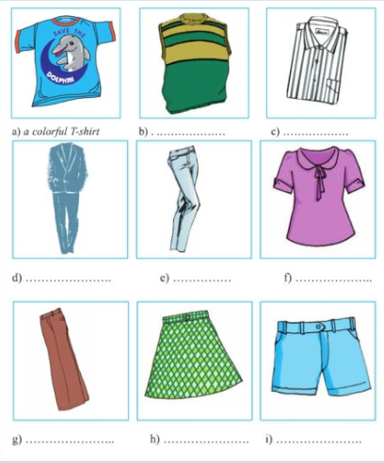
1. a colorful T-shirt
2. a plaid skirt
3. a plain suit
4. a short-sleeved blouse
5. a sleeveless sweater
6. a striped shirt
7. baggy pants
8. faded jeans
9. blue shorts
Suggested answers:
a - 1. a colorful T-shirt
b - 5. a sleeveless sweater
c - 6. a striped shirt
d - 3. a plain suit
e - 8. faded jeans
f - 4. a short - sleeved blouse
g - 7. baggy pants
h - 2. a plaid skirt
i - 9. blue shorts
Task 2: Work in small groups. Write two more questions for the last section of this survey about students' wear. Then interview members of another group. The words in section a) may help you.
(Thực hành từng nhóm nhỏ. Viết hai câu hỏi nữa cho phần cuối của khảo sát này về sự ăn mặc của học sinh. Sau đó phỏng vấn các thành viên của một nhóm khác. Những từ ở bài tập 1 có thể giúp em.)
Casual clothes: What do you usually wear on the weekend?
Why do you wear these clothes?
Favorite clothes: What is your favorite type of clothing? Why?
School uniform: Is it comfortable?
What color is it?
Clothes for special occasions:

Suggested answers:
What do you usually wear on special occasions?
Where do you often buy these clothes?
Bài 3
Task 3. Now report the results of your survey.
(Bây giờ báo cáo kết quả cuộc khảo sát của bạn.)
______________________________________________________________________________________________________________________________________________________________________________________________________________________________________________________________________________________________________________________________________________________________________________________________________________________________________________________________________________

Suggested answers::
I have asked 10 friends in group 4 and I find out that:
- 3 people usually wear jeans and T - shirt on the weekend because they help them easy to attend outdoors activities.
- 4 girls said they loved the traditional dress because it makes them look more graceful.
- all of them said they liked their uniform.
- girls in this group usually wear skirts and shirt and the boys usually wear jeans and white shirt on special occasions. They said that their parents took them to different shops to by these clothes.

LISTEN
You will hear a public announcement about a lost little girl called Mary. Listen and check (√) the letter of the correct picture to show what Mary is wearing.
(Bạn sẽ nghe thấy một thông báo công khai về một cô bé bị lạc gọi là Mary. Lắng nghe và đánh dấu (v) vào hình ảnh chính xác để hiển thị những gì Mary đang mặc.)
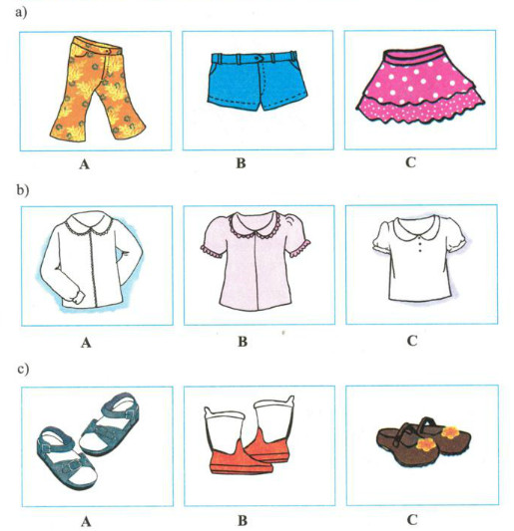

Task 1: Listen to figure out if these information is true or false? Mark (X) the box then correct the false information.
 | True | False
1. They last saw Mary at the exit of the amusement park.
.....................................................................................
2. Mary didn’t bring along anything but a large doll.
......................................................................................
3. She is reported to wear a long - sleeved blouse and brown shoes.
.........................................................................................
4. Her mother is waiting for her at the Information Desk.
...........................................................................................

Task 2: Listen again and check (√) the letter of the correct picture to show what Mary is wearing.
___________________________________________________________________________

Suggested answers:
Task 1:
- False. They last saw Mary near the main entrance to the Car Fair.
- True
- True
- False. Her father is waiting for her at the Information Desk
Task 2:
1 - B: blue shorts
2 - A: a long – sleeved blouse
3 - C: brown shoes
Tapescript:
Attention please. Here is a special announcement. A little girl is reported missing. She was last seen 20 minutes ago near the main entrance to the Car Fair. Her name’s Mary and she is 3 years old. She has short dark hair. She’s wearing shorts – blue shorts and a long – sleeved blouse. She’s wearing a pair of shoes – brown shoes. She may be carrying a large doll.
If you see Mary, please bring her to the Information Desk. Her father’s waiting for her there. Thank you.
WRITE

This is how to present one side of an argument. It is used to persuade readers to believe or do something. An argument should have:
(Đây là cách trình bày 1 ý kiến của một bên trong một bài tranh luận. Nó được sử dụng để thuyết phục người đọc tin hay làm 1 điều gì đó. Một bài tranh luận nên có:)

 | Organization | Language
Introduction | lets the reader know the writer’s point of view | My opinion is ...  I think ...
Series of arguments | presents arguments in a logical way (one in each paragraph), gives examples where possible | Firstly, ...  Secondly, ...  Finally....
Conclusion | sums up the argument | Therefore. ...  In conclusion. ...

Task 1: Read the topic and Outline A. Then read the passage.
(Hãy đọc chủ đề và dàn bài A. Sau đó đọc bài.)
Secondary school students should wear uniforms
Outline A
Wearing uniforms:
- encourages students to be proud of their school because the uniforms bear their school’s name.
- helps students feel equal in many ways, whether they are rich or poor.
- is practical. No need to think of what to wear every day.
I think it is necessary for secondary school students to wear uniforms when they are at school.
Firstly, wearing uniforms encourages students to be proud of being students of their school because they are wearing the uniforms with labels bearing their school's name.
Secondly, wearing uniforms helps students feel equal in many ways, whether they are rich or poor.
Finally, wearing uniforms is practical. You don’t have to think of what to wear every day.
Therefore, students in secondary schools should wear uniforms.

Task 2: Now write a paragraph of 100-150 words. But this time you support the argument that secondary school students should wear casual clothes. Outline B may help you.
(Bây giờ các bạn hãy viết một đoạn văn khoảng 100 đến 150 từ. Nhưng lần này bạn hãy ủng hộ cho ý kiến rằng học sinh trung học nên mặc thường phục. Dàn bài B có thể giúp bạn.)

Secondary school students should wear casual clothes
Outline B
Wearing casual clothes:
- makes students feel comfortable.
- gives students freedom of choice (sizes, colors, and fashions, etc.).
- makes students feel self-confident when they are in their favorite clothes.
- makes school more colorful and lively.

__________________________________________________________________________________________________________________________________________________________________________________________________________________________________________________________________________________________________________________________________________________________________________________________________________________________________________________________________________________________________________________________________________________________________________________________________________________________________________________________________________________________________________________________________________________________________________________________________

Suggested answers:
I think it is necessary for secondary school students to wear casual clothes when they are at school.
Firstly, casual clothes make all students feel comfortable. They can wear convenient clothes for outdoors and indoors activities. Secondly, casual clothes can give students freedom of choice. They can choose what sizes, colors, and fashions of clothing they love. Moreover, casual clothes can make students feel self-confident when they are in their favorite clothes because they choose these clothes carefully and ensure them to be well-dressed. Finally, it makes the school more colorful and lively with different styles, colors and types of clothes.
In conclusion, in my opinion, all the secondary school students should wear casual clothes.

